**WEEK 2 – Advanced SQL Exercises for Online Retail Store**

Exercise 1: Ranking and Window Functions

Goal: Use ROW_NUMBER(), RANK(), DENSE_RANK(), OVER(), and PARTITION BY.

Scenario:

Find the top 3 most expensive products in each category using different ranking functions.

Steps:

1. Create a database “ Storedb ”.

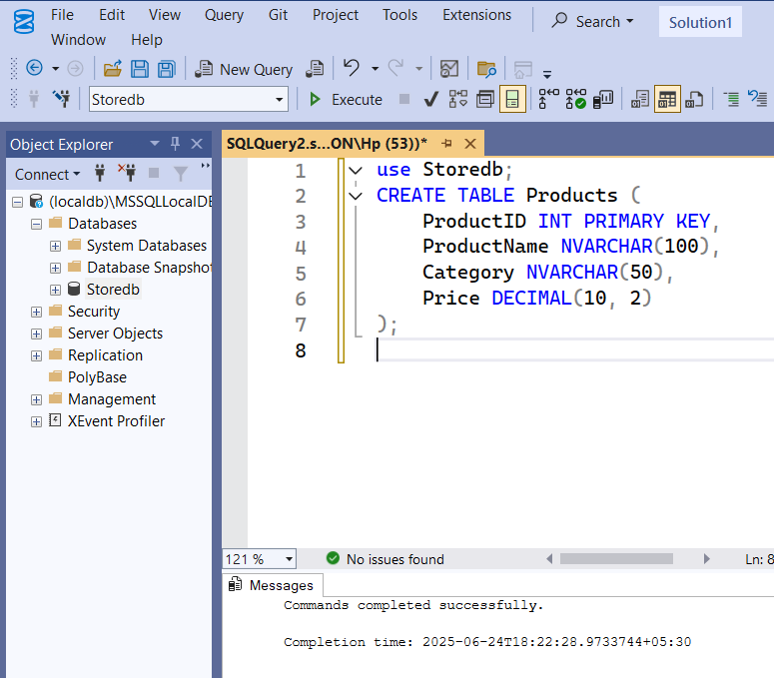

1. Insert Data in the database Storedb.

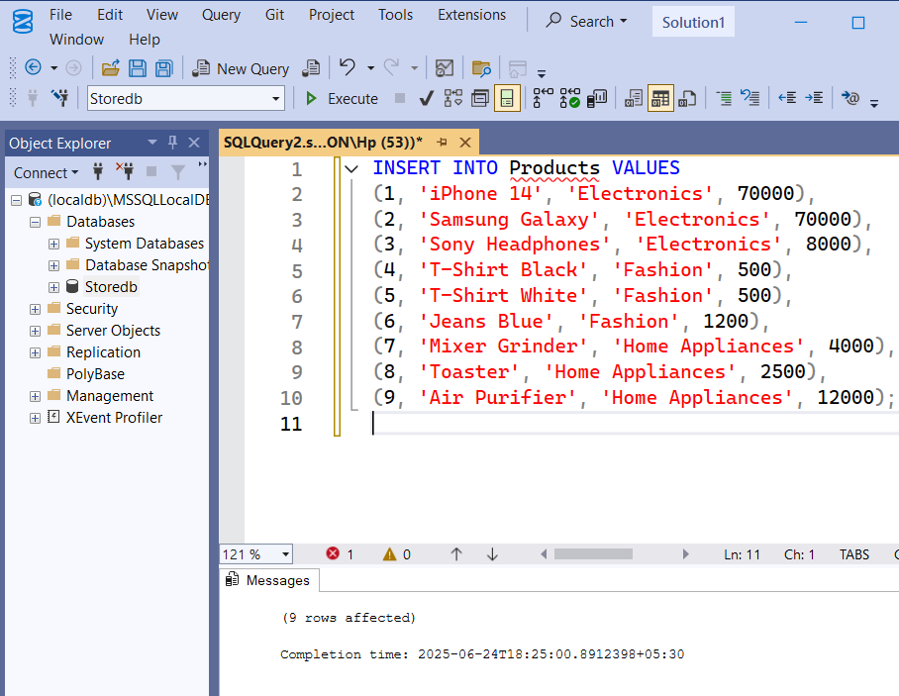

1. Use ROW_NUMBER() to assign a unique rank within each category and also PARTITION BY Category and ORDER BY Price DESC

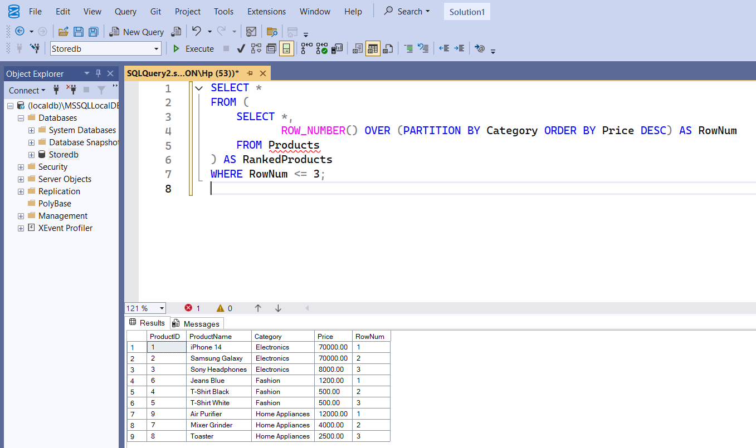

1. Use RANK() and DENSE_RANK() to compare how ties are handled with PARTITION BY Category and ORDER BY Price DESC

